CLR Enrichment

Phase 1

Date: 03/16/2021

Authors: Priyank Verma

Prepared for: Prosight

# Contents

**Contents** **2**

**Document History Tracker** **3**

**Project Overview: Goal and Objectives** **4**

Goal 4

Objectives 4

**Project Scope and Challenges** **5**

Scope 5

In Scope 5

Out of Scope 5

**Design Overview** **6**

**New Fields** **7**

Claim 7

Policy 7

Feature 7

New Fact Tables 7

Other Tables 7

DimProducer 7

DimAccount 8

**Implementation** **9**

Development 9

Validation 9

Production 9

**Role & Responsibilities** **10**

# 

# Document History Tracker

* Please add the latest changes to the top row.

|  |  |  |  |  |
| --- | --- | --- | --- | --- |
| Date | Description of change | Owner | Change Approved  by (Stakeholders) | Version |
| 03/16/2021 | CLR Enrichment | Priyank Verma | Manish Munshi | 1.0 |

# Project Overview: Goal and Objectives

## Goal

* Add new fields and tables into Prosight_Edw DB.

## Objectives

* Identifying New fields to be added to DB
* Addition of new fields to existing Claim, Feature and Policy tables.
* Addition of new fields to Producer and Account dimension table.
* Introducing new Fact and Dimension tables related to Subrogation, Salvage, Litigation, Tender and Litigation.

# Project Scope and Challenges

## Scope

### In Scope

* ETL Process change and Database Changes
  + Design Schema and structure of new tables and new fields.
  + Modifying and creation of new tables and fields.
  + Making changes to the existing ETL pipeline.
  + Testing and deployment of the modified process.

### Out of Scope

* Reporting
  + Making changes to the existing SSRS reports and reporting tables.

# Design Overview

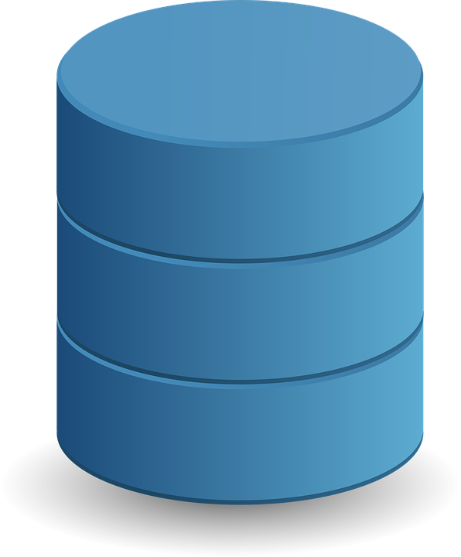

**RDM**

**URS/SDS**

**SOURCE**



**RAW**



**STG**



**STG FOR DIM**



**DIM**



**FACT**

**PROSIGHT_ EDW**

Fig 1. ETL Flow

The table below shows the overview of changes.

|  |  |
| --- | --- |
|  | **Count** |
| New Fields In Existing Fact Tables | 13 |
| New Dim Tables | 31 |
| New Staging Tables | 34 |
| New Fact Tables | 4 |

## 

# New Fields

## Claim

*Total New Fields in Claim Table: 4*

List of New fields:

1. CatastropheKey
2. WcClaimTypekey
3. AdjusterPolicyYear
4. ClaimTriagekey

## Policy

*Total New Fields in Policy Table: 4*

List of New fields:

1. NAICSKey
2. Over90IndicatorKey
3. PolicyCurrentStatusKey
4. BalanceDue

## Feature

*Total New Fields in Feature Table: 3*

List of New fields:

1. AslobKey
2. SchedulePGroupKey
3. TotalLossIndicatorKey

## New Fact Tables

*Total New Fact Tables: 4*

List of New Fact Tables:

1. Litigation
2. Subrogation
3. Salvage
4. Tender

## Other Tables

### DimProducer

**New Field Added:** ProducerHasInforcePolicy

### DimAccount

**New Field Added:** AccountHasInforcePolicy

Detailed Description of the fields with their data type and source can be found in the excel here.

# 

# Implementation

## Development

**Server:** edw-dev-db

**Database:** Prosight_Edw

The development was done on the above mentioned server and database.

A daily refresh job has been scheduled on the development server.

**Job Name:** CLR_Channel1_2_HF3

**SSIS Package:** \\edw-dev-db\isaac\SSIS\CLR-Channel-1,2\DEV_PSEDW_SSIS_FullRefresh.dtsx

## Validation

A reconciliation dashboard has been created to compare important money buckets Production and Development reporting tables.

Link to the Dashboard: <https://climbergpsdev.prosight.net/#/workbooks/1749/views>

## Production

**Server:** edw-prod-db

**Database:** Prosight_Edw

The below mentioned production job on ETLSQLPR1003 server will be updated.

**Job Name:** DAT-ProsightEDWMart

# 

# Role & Responsibilities

|  |  |  |  |
| --- | --- | --- | --- |
| **Resource** | **Role** | **Role Description** | **Organization** |
| Manish Munshi | Product Owner |  | Prosight |
| Bhaumik Patel | Technical Lead |  | Quantiphi |
| Priyank Verma | Data Engineer |  | Quantiphi |
| Jayesh Pujare | Cloud Engineer |  | Quantiphi |
| Pallavi Kadam | Data Engineer |  | Quantiphi |